Component creation 2

Creating three components Card1 ,Card2 ,Card3

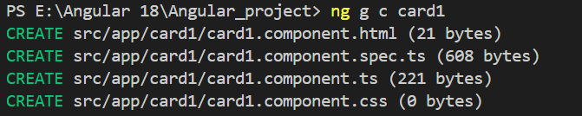

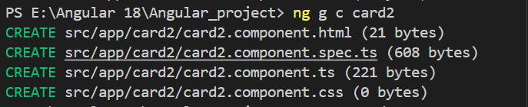

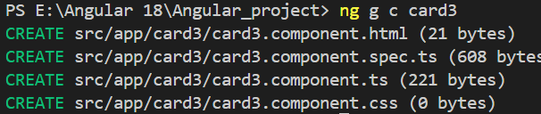

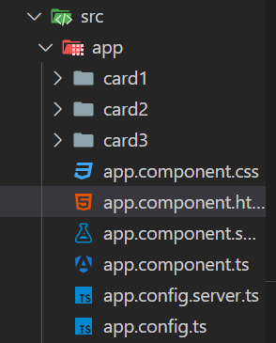

Then create card like structures in each components html page apply css to its css page

**Card1 > card1.component.html**

<div class="product-card">

    <img src="https://static.vecteezy.com/system/resources/previews/033/501/763/non_2x/laptop-with-blue-smoke-on-a-black-background-ai-generated-free-photo.jpeg" alt="Product Image" class="product-image">

    <h2 class="product-name">Lenovo ideaPad</h2>

    <p class="product-price">$199.99</p>

    <p class="product-description">Lorem ipsum dolor sit amet consectetur adipisicing elit. Necessitatibus accusamus, et error eligendi consequatur, iure autem quaerat porro dolor provident ab id a magnam dignissimos ut nobis aliquid quo odit?</p>

    <button class="btn btn-primary">Add to Cart</button>

    <button class="btn btn-secondary">View Details</button>

</div>

**Card1 > card1.component.css**

.product-card {

    border: 1px solid #ddd;

    padding: 16px;

    border-radius: 8px;

    max-width: 300px;

    text-align: center;

    background-color: #fef9c7; /* Light background color */

    box-shadow: 0 4px 8px rgba(0, 0, 0, 0.1); /* Box shadow */

}

.product-image {

    max-width: 100%;

    height: auto;

    border-radius: 8px;

    margin-bottom: 16px;

}

.product-name {

    font-size: 1.5em;

    margin-bottom: 8px;

}

.product-price {

    color: #b12704;

    font-size: 1.2em;

    margin-bottom: 8px;

}

.product-description {

    font-size: 1em;

    margin-bottom: 16px;

}

.btn {

    padding: 10px 20px;

    margin: 5px;

    border: none;

    border-radius: 4px;

    cursor: pointer;

}

.btn-primary {

    background-color: #007bff;

    color: white;

}

.btn-secondary {

    background-color: #6c757d;

    color: white;

}

**Card2 > card2.component.html**

<div class="product-card">

    <img src="https://img.freepik.com/premium-photo/person39s-laptop-sits-green-grassy-field-possibly-outdoors-study-work_153912-363934.jpg?semt=ais_hybrid" alt="Product Image" class="product-image">

    <h2 class="product-name">Asus vivobook15</h2>

    <p class="product-price">$219.99</p>

    <p class="product-description">Lorem ipsum dolor sit amet, consectetur adipisicing elit. Alias blanditiis exercitationem at. Explicabo molestias non autem </p>

    <button class="btn btn-primary">Add to Cart</button>

    <button class="btn btn-secondary">View Details</button>

</div>

**Card2 > Card2.component.css**

.product-card {

    border: 2px solid #333;

    padding: 20px;

    border-radius: 12px;

    max-width: 350px;

    text-align: center;

    background-color: #e0f7fa; /* Light blue background color */

    box-shadow: 0 6px 12px rgba(0, 0, 0, 0.2); /* Stronger box shadow */

}

.product-image {

    max-width: 100%;

    height: auto;

    border-radius: 12px;

    margin-bottom: 20px;

}

.product-name {

    font-size: 1.8em;

    margin-bottom: 10px;

    color: #00796b; /* Dark teal color */

}

.product-price {

    color: #d32f2f; /* Dark red color */

    font-size: 1.4em;

    margin-bottom: 10px;

}

.product-description {

    font-size: 1.1em;

    margin-bottom: 20px;

    color: #555; /* Dark gray color */

}

.btn {

    padding: 12px 24px;

    margin: 8px;

    border: none;

    border-radius: 6px;

    cursor: pointer;

    font-size: 1em;

}

.btn-primary {

    background-color: #0288d1; /* Blue color */

    color: white;

}

.btn-secondary {

    background-color: #7b1fa2; /* Purple color */

    color: white;

}

**Card3 > card3.component.html**

<div class="product-card">

    <img src="https://cdn.mos.cms.futurecdn.net/3kcgKLkfPRbskpsYzW239d.jpg" alt="Product Image" class="product-image">

    <h2 class="product-name">Samsung Bookpad</h2>

    <p class="product-price">$329.99</p>

    <p class="product-description">Lorem ipsum dolor sit amet consectetur, adipisicing elit. Quia reprehenderit minus tempore accusantium, reiciendis vel architecto. Necessitatibus minus rerum illo at nemo?</p>

    <button class="btn btn-primary">Add to Cart</button>

    <button class="btn btn-secondary">View Details</button>

</div>

**Card3 > Card3.component.css**

.product-card {

    border: 1px solid #ccc;

    padding: 15px;

    border-radius: 8px;

    max-width: 300px;

    text-align: center;

    background-color: #f9f9f9; /* Light gray background color */

    box-shadow: 0 4px 8px rgba(0, 0, 0, 0.1); /* Softer box shadow */

}

.product-image {

    max-width: 100%;

    height: auto;

    border-radius: 8px;

    margin-bottom: 15px;

}

.product-name {

    font-size: 1.6em;

    margin-bottom: 8px;

    color: #333; /* Dark gray color */

}

.product-price {

    color: #e91e63; /* Pink color */

    font-size: 1.2em;

    margin-bottom: 8px;

}

.product-description {

    font-size: 1em;

    margin-bottom: 15px;

    color: #666; /* Medium gray color */

}

.btn {

    padding: 10px 20px;

    margin: 6px;

    border: none;

    border-radius: 4px;

    cursor: pointer;

    font-size: 0.9em;

}

.btn-primary {

    background-color: #2196f3; /* Blue color */

    color: white;

}

.btn-secondary {

    background-color: #9c27b0; /* Purple color */

    color: white;

}

Then import the components name into the app.component.ts page import [] section

  imports: [Card1Component,Card2Component,Card3Component],

**app.component.ts**

import { Component } from '@angular/core';

import { RouterOutlet } from '@angular/router';

import { Card1Component } from './card1/card1.component';

import { Card2Component } from './card2/card2.component';

import { Card3Component } from './card3/card3.component';

@Component({

  selector: 'app-root',

  imports: [Card1Component,Card2Component,Card3Component],

  templateUrl: './app.component.html',

  styleUrl: './app.component.css'

})

export class AppComponent {

  title='Angular_project';

}

**Then call the page**

**Arrange in a row then apply style at the app.component.css page**

**App.component.css**

.card-container {

    display: flex;

    justify-content: space-around;

    align-items: center;

    padding: 20px;

    border-radius: 8px;

}

**App.component.html**

<div class="card-container">

    <app-card1></app-card1>

    <app-card2></app-card2>

    <app-card3></app-card3>

</div>

**OutPut :**

